Digitizing the Ma’lel Dunes: Analysing Trail Conditions on Parabolic Dunes
Mackenzie Cahill, Alexander Gorman, Ty Muhovich

Abstract:
It is well known that health and protection of the flora and fauna residing within the Ma’lel dunes system is dependent upon visitors, either human, canine, or equine, utilizing the designated trails so as to minimize damage caused by trampling (BLM, 2016). This is best achieved when the public has access to accurate maps of trail systems. So the question is, how accurate is the Bureau of Land Management (BLM) trail map of the Ma’lel dunes. To test this map’s accuracy, we collected data from both the North and South trail systems and then digitized this data and compare our trail paths with those outlined in the BLM original. Data was collected with GPS by marking waypoints every few paces along all the trails which were accessible and clearly marked off.

Introduction:
The Ma’lel dunes system is an ecological jewel of Humboldt County located just north of Manilla (Figure 2.). The area we call the Ma’lel dunes is a public land coastal access point; open to hikers, equestrians, dog-walkers, wildlife hobbyists, and anyone who wants to explore the local dunes. This is also a cooperatively managed area split into two halves (Figure 1.). The North half is managed by the Humboldt Bay National Wildlife Refuge (HBNWR), and the South is managed by the Bureau of Land Management (BLM). What makes Ma’lel so unique is its incredible diversity of habitats, the beaches, sand dunes, dune forests, salt marshes, and even seasonal freshwater sloughs. Because this complex environment is fragile in nature and very susceptible to trampling, it is expected for visitors to only travel on the designated trails and open sandy areas. The BLM website has a link to a map of all the trail systems, highlighted in different colors, for the Ma’lel dunes area. While the BLM map shows clearly marked trails, in real life the trails are much more difficult to discern and is so do to two reasons. First there are very few signposts or markers indicating the direction of different trails as well as many markers being completely absent, as we saw first hand. The other reason involves the dunes themselves, the dunes are a dynamic habitat which move across the landscape as wind pushes grains of sand inland towards the forest (FWS, 2016). Therefore, it becomes a challenge to plot a fixed trial on landscape which is constantly changing. Our main objective for this project was to see if the trials on the BLM map match the real trails on the dunes.
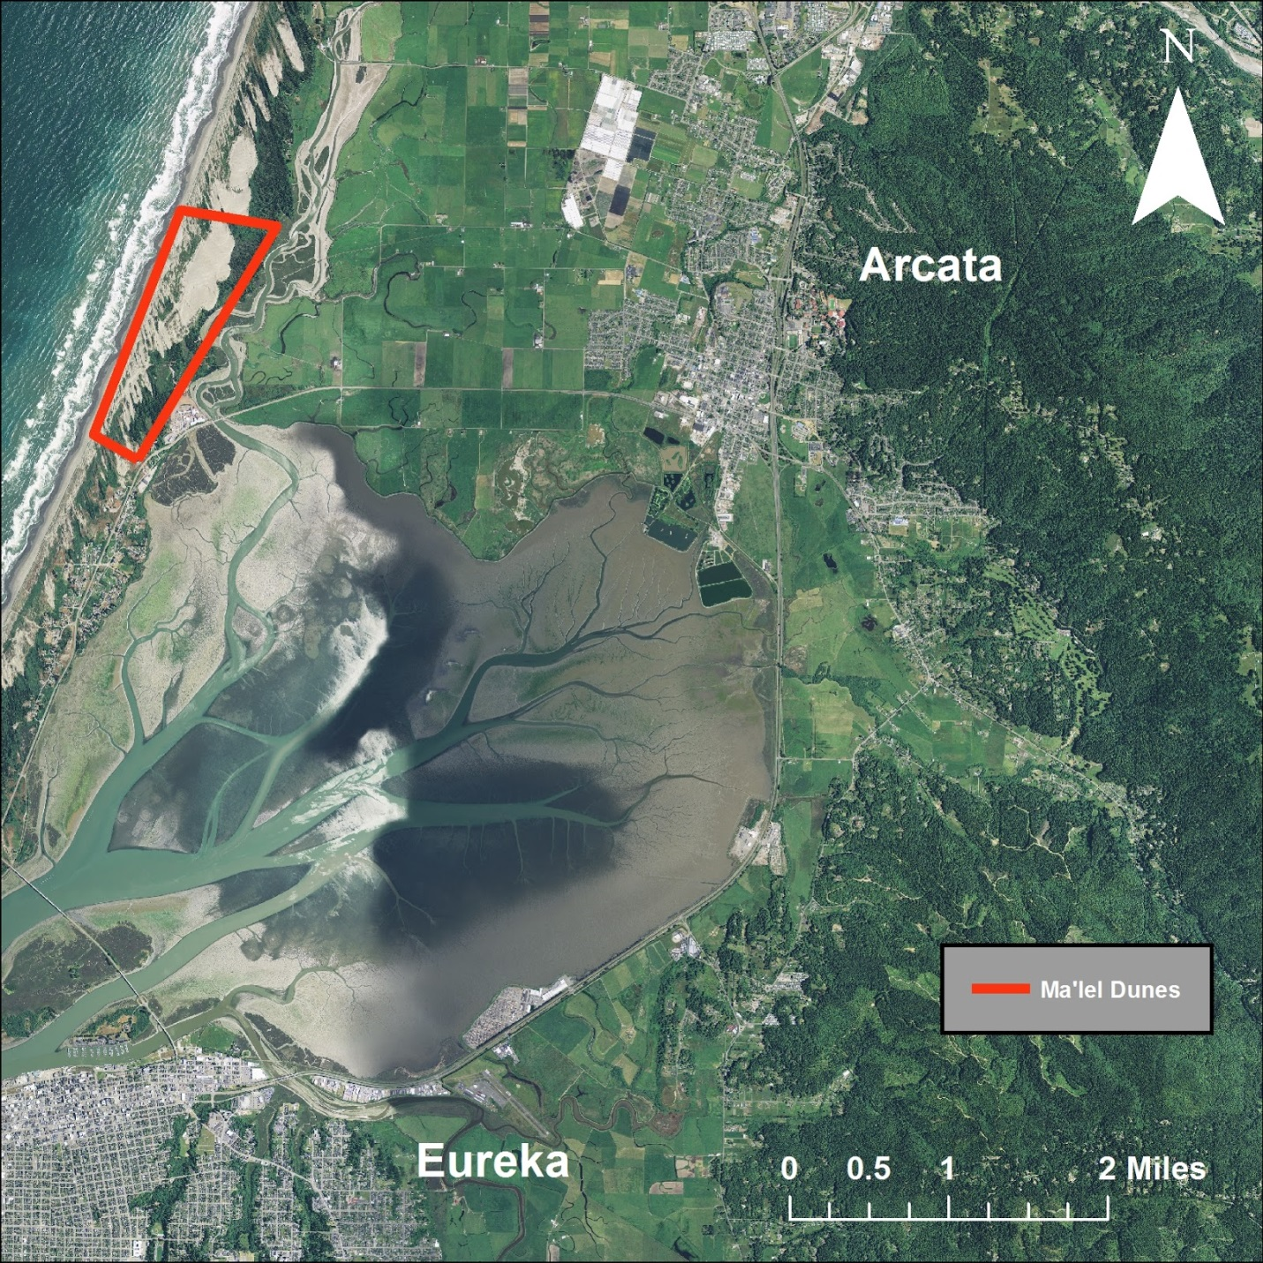
Figure 1. Locator map displaying the location of the Ma’lel Dunes relative to Humboldt Bay.
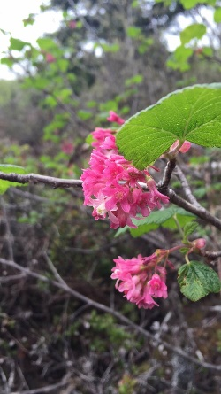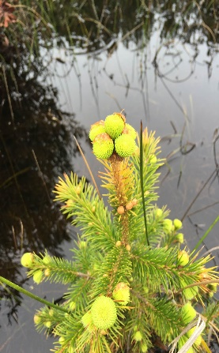
Figure 2. Photos displaying the diverse flora and fauna present at the Ma’lel Dunes.
Photo Credit: Alex Gorman

Methods:
We started off the project by first collecting our field data from both the Ma’lel Dunes north and south. This was done by walking all of the trails with a Garmin handheld GPS unit, and at every change in direction marking a waypoint later be used in our data analysis. This was done first for the northern section of the dunes, and then replicated the same way for the southern portion of the dunes; in total more than 600 waypoints were marked. A few issues that occurred while we were collecting our field data were that the trial markers were frequently missing, damaged, or out of place, the trails going directly through the dunes themselves were often unrecognizable, and seasonal flooding made some trails inaccessible (Figure 3.).
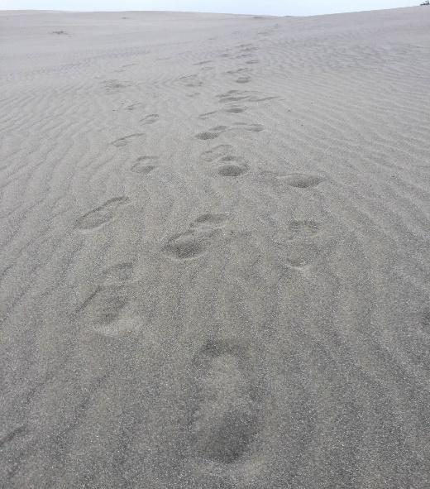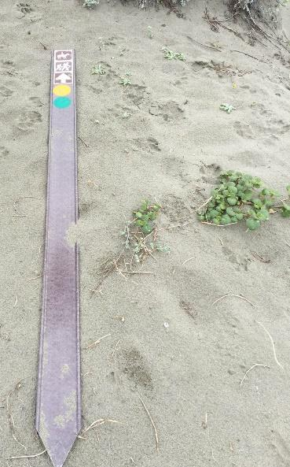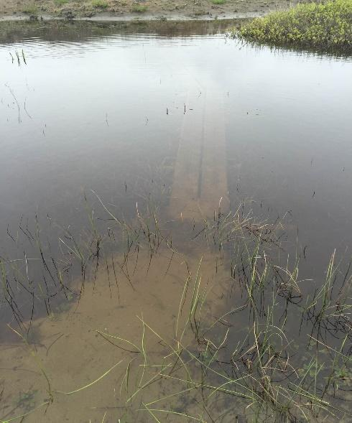
Figure 3. Photos displaying the obstacles we ran into while collecting our field data.
Photo Credit: Alex Gorman

Once all of the field data was collected, we uploaded the data to Minnesota Department of Natural Resources (DNR) Garmin program in order to create a text file of our waypoints. The text file was then loaded into ArcMap 10.2.2 by Esri Inc. where the text file was put into a format that displayed X and Y data, with X representing longitude and Y representing latitude, this created a new layer displaying the location of all the waypoints that were taken. Along with this newly created layer a National Agricultural Imagery Program (NAIP) image of the Ma’lel Dunes was loaded into ArcMap. The project tool was then used to change the Projected Coordinate System (PCS) to North American Datum 1983 (NAD83) so that the NAIP imagery matched the PCS of our newly created points layer. Then while in editor mode, the point to line data management tool was used to convert all of the individual points into solid lines. This was done by selecting a small number of points to convert to a line, then creating a new layer from that feature. Running the tool for all the waypoints at once only connected every line possible even with Sort Field (optional) Indent selected. Once multiple layers were created they were merged together to create one single layer. This process was repeated until all of the points were converted into lines and merged into a single layer. From here, we highlighted the parts of the trails where we noted they were flooded and difficult to stay on the designed trail. Once the northern and southern trials were made into layers, maps were created showing the current location of the trials.

Results:
Given the data we collected and analysed, we were able to make a displaying the current trail locations of the northern section of the Ma’lel Dunes (Figure 4.), as well as the current trail locations of the southern section of the Ma’lel Dunes (Figure 5.). A table is included to show the length of flooded trails.

Flooded Trail Names | Length in Meters
Dap Loop (doppp) | 37.88
Du’k (duck) | 43.85
Ledik (led-eek) | 72.74
Kimuk (kee-muk) | 85.84
Hout (hoot) | 112.37
Table 1. Table displays how many meters of each trail is flooded.

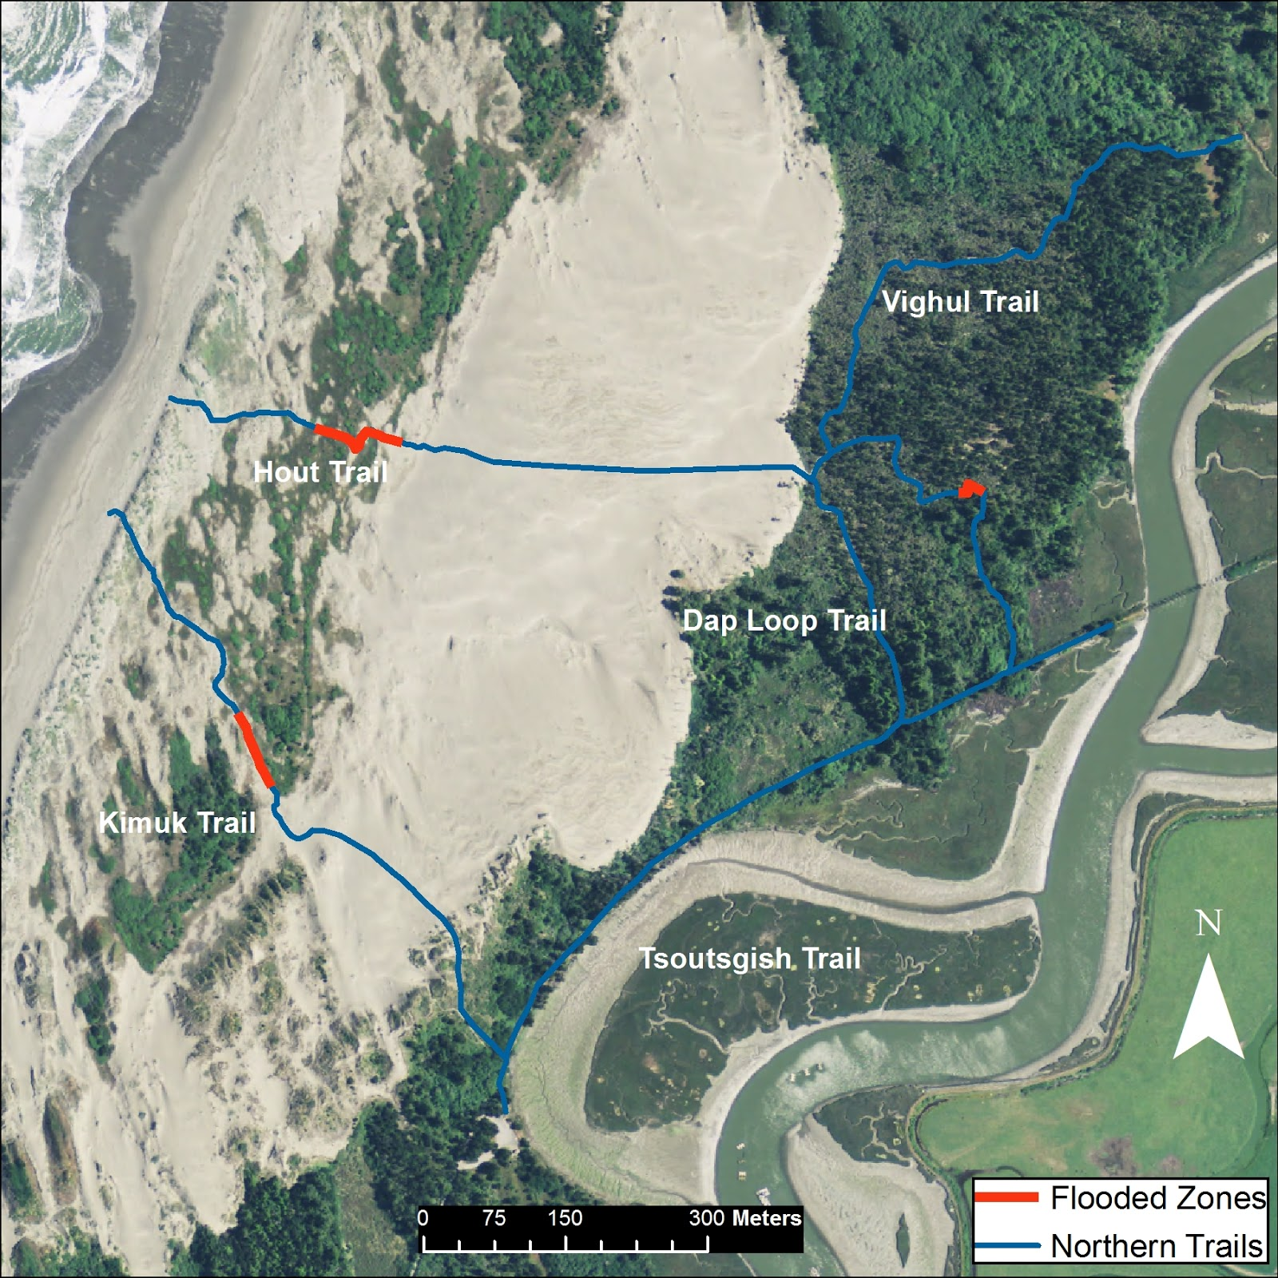
Figure 4. Map displaying current trail locations with currently flooded areas highlighted in red on Ma’lel Dunes North.

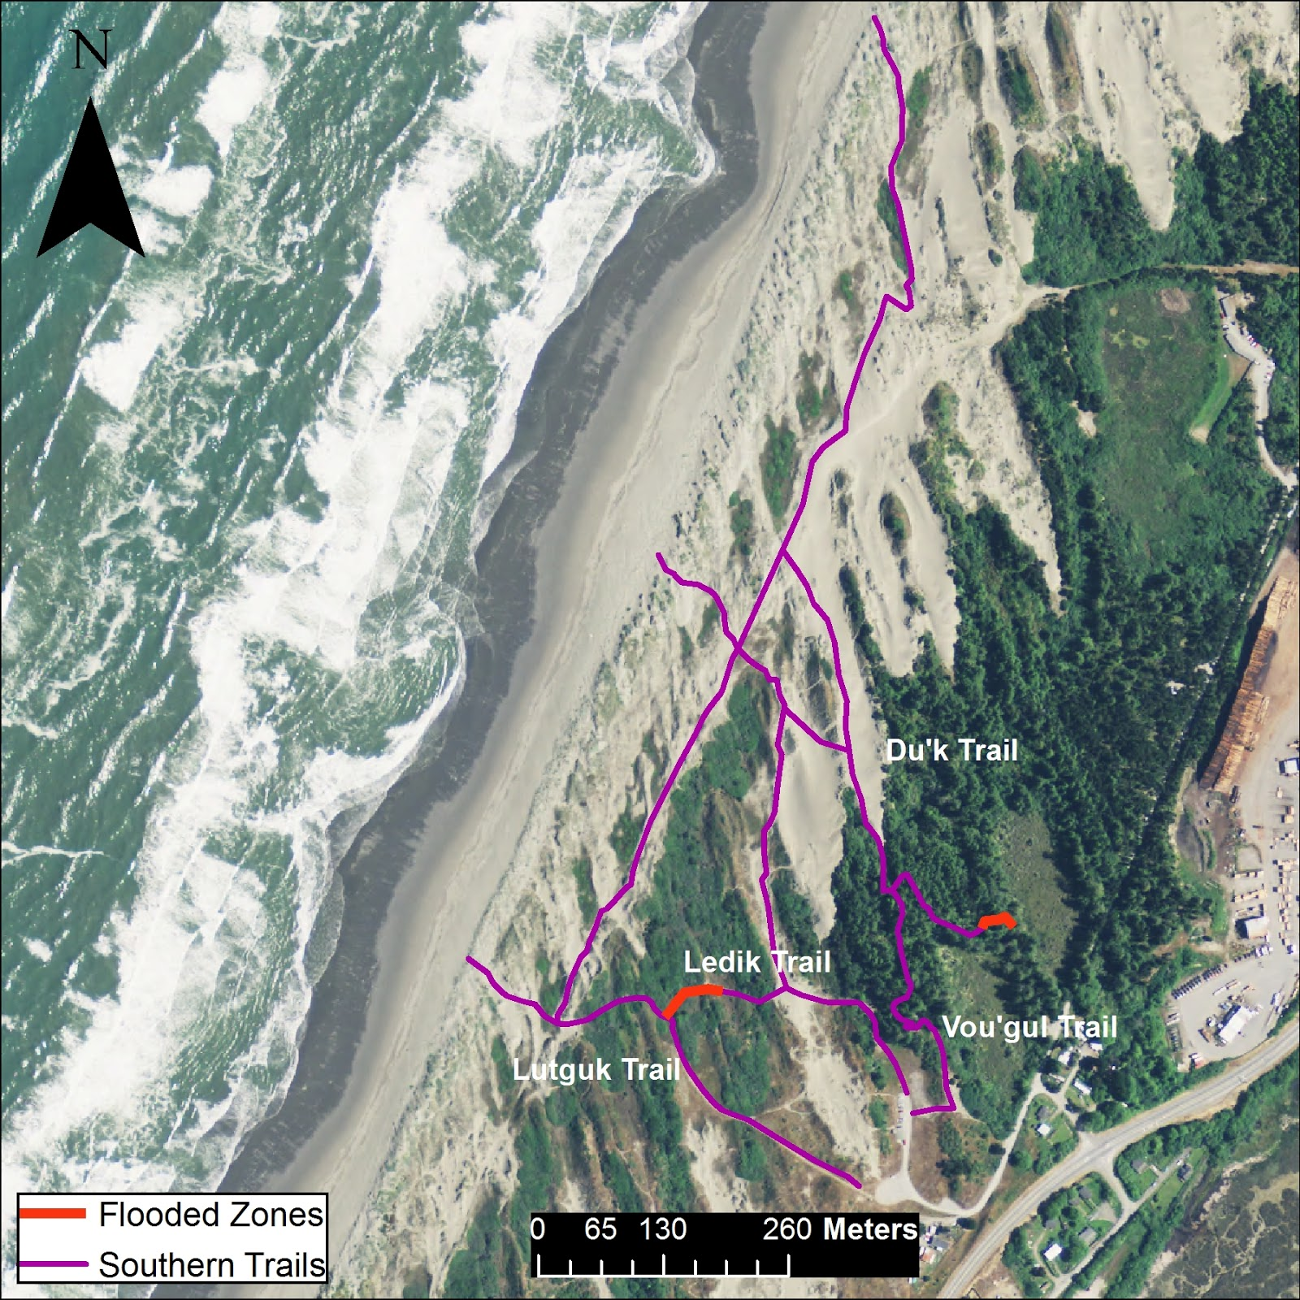
Figure 5. Map displaying current trail locations with currently flooded areas highlighted in red on Ma’lel Dunes South.

Conclusion:
Dune systems, especially those as dynamic as Ma’lel, are challenging habitats to establish and maintain constantly fixed trails. The Ma’lel dunes system is characterized by the ever changing nature of the landscape, along with great seasonal differentiation. The Ma’lel dunes are an example of a parabolic dune system and are named as such for the parabolic curved shape that the crests of the dunes form (FOD, 2014). The dunes themselves are simply the result of wind and sand accumulation, and it is these two components that also cause dunes to grow as well as travel. As wind moves across the landscape it pushes grains of sand further inland and eventually meets up with the Beach Pine forest, where the forest edge is engulfed by the accumulated sand. This conveyor belt of dunes and sand being pushed further inland is fed with sand from the beach and is broken up by islands of stabilized dunes which are in fixed positions because small coastal vegetation has colonized the dune (FOD, 2014). Now when establishing a trail through the dunes, the trail can be clearly seen in the vegetated areas, however the rest of the open sand dune area is constantly moving. In these open areas only an approximation can be made of where the trail is, because the path that you follow one day may be completely washed away or buried over in a matter of weeks (BLM, 2016).

The open sand is not the only area in Ma’lel where trails are susceptible to change. In the stabilized dune area, large depressions or bowls in the sand are formed by surrounding dune crests. Because of Ma’lel’s geographic location here along the Coast of Humboldt County, it receives copious amounts of precipitation nearly year round. This precipitation collects in the depressions and forms what we call a freshwater slough. Basically they are semi-seasonal ponds that fill up around the bases of many dunes. This seasonal flooding leads to sloughs forming in areas where they are otherwise not consistently present as well as flooding over the parameter of sloughs which are usually present year round. Because we collected our data in the end of winter/ beginning of spring, we came across many of these sloughs. The flooding in the dunes actually covers over many sections of the trails, and for the average visitor it prevents them from following the established trail paths. Often unofficially marked trails are formed around the edges of sloughs by visitors who simply avoiding getting wet.

Acknowledgements:
We would like to thank Humboldt State University for providing us with the equipment and space used to conduct this project. As well as Buddhika Madurapperuma and Jim Graham for being very responsive and helpful.

Bibliography:
Burea of Land Managment, Ma-le'l Dunes Cooperative Management Area. Arcata Field Office, Web.May, 2016.
http://www.blm.gov/ca/st/en/fo/arcata/ma-le_l_dunes_cooperative.html
Friends of the Dunes, Biologist Informative Presentation. Lanphere Dunes Nature Center. Oct, 2014.
http://www.friendsofthedunes.org/nature-center/
http://www.fws.gov/uploadedFiles/Region_8/NWRS/Zone_1/Humboldt_Bay_Complex/Hum bolt _Bay/Sections/Documents/Ma-le'lSummary2014%282%29.pdf.
Garmin handheld GPS from Humboldt State University’s Forestry Department.
NAIP Image of Humboldt County from Humboldt County GIS download.
http://www.humboldtgov.org/276/GIS-Data-Download
U.S.Fish and Wildlife Service; Humboldt Bay National Wildlife Refuge. Ma-le’l Dunes Restoration Summary and Photo Documentation. PDF. Apr, 2016.

